Recruitment Information Pack
Kitchen Supervisor

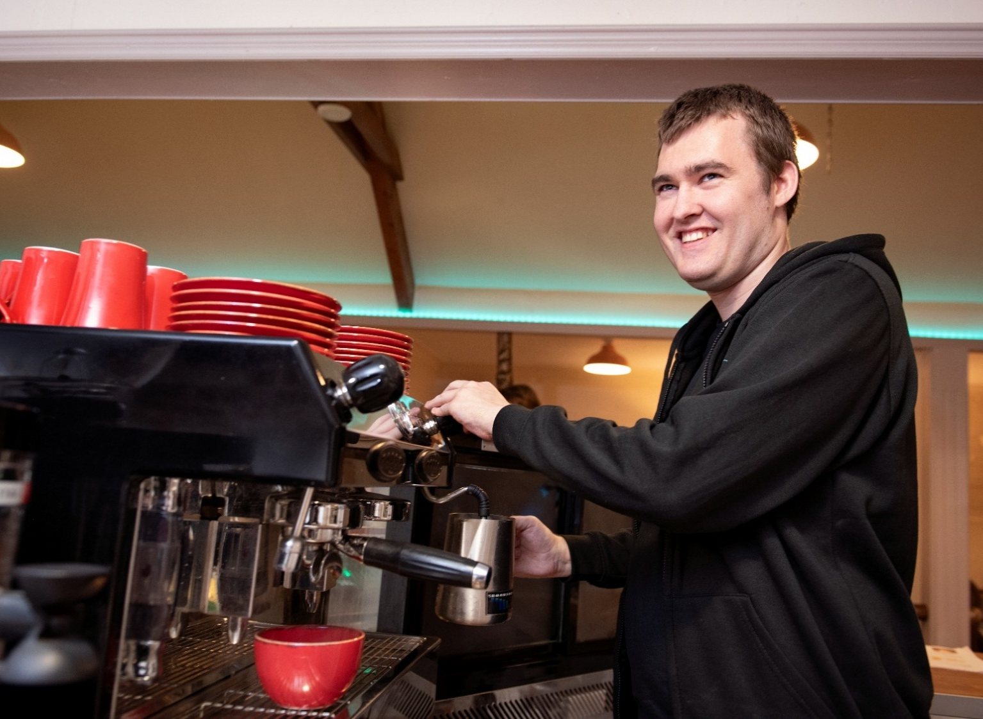
Area 43
35 Pendre
Cardigan
SA43 1JS
01239 614 566
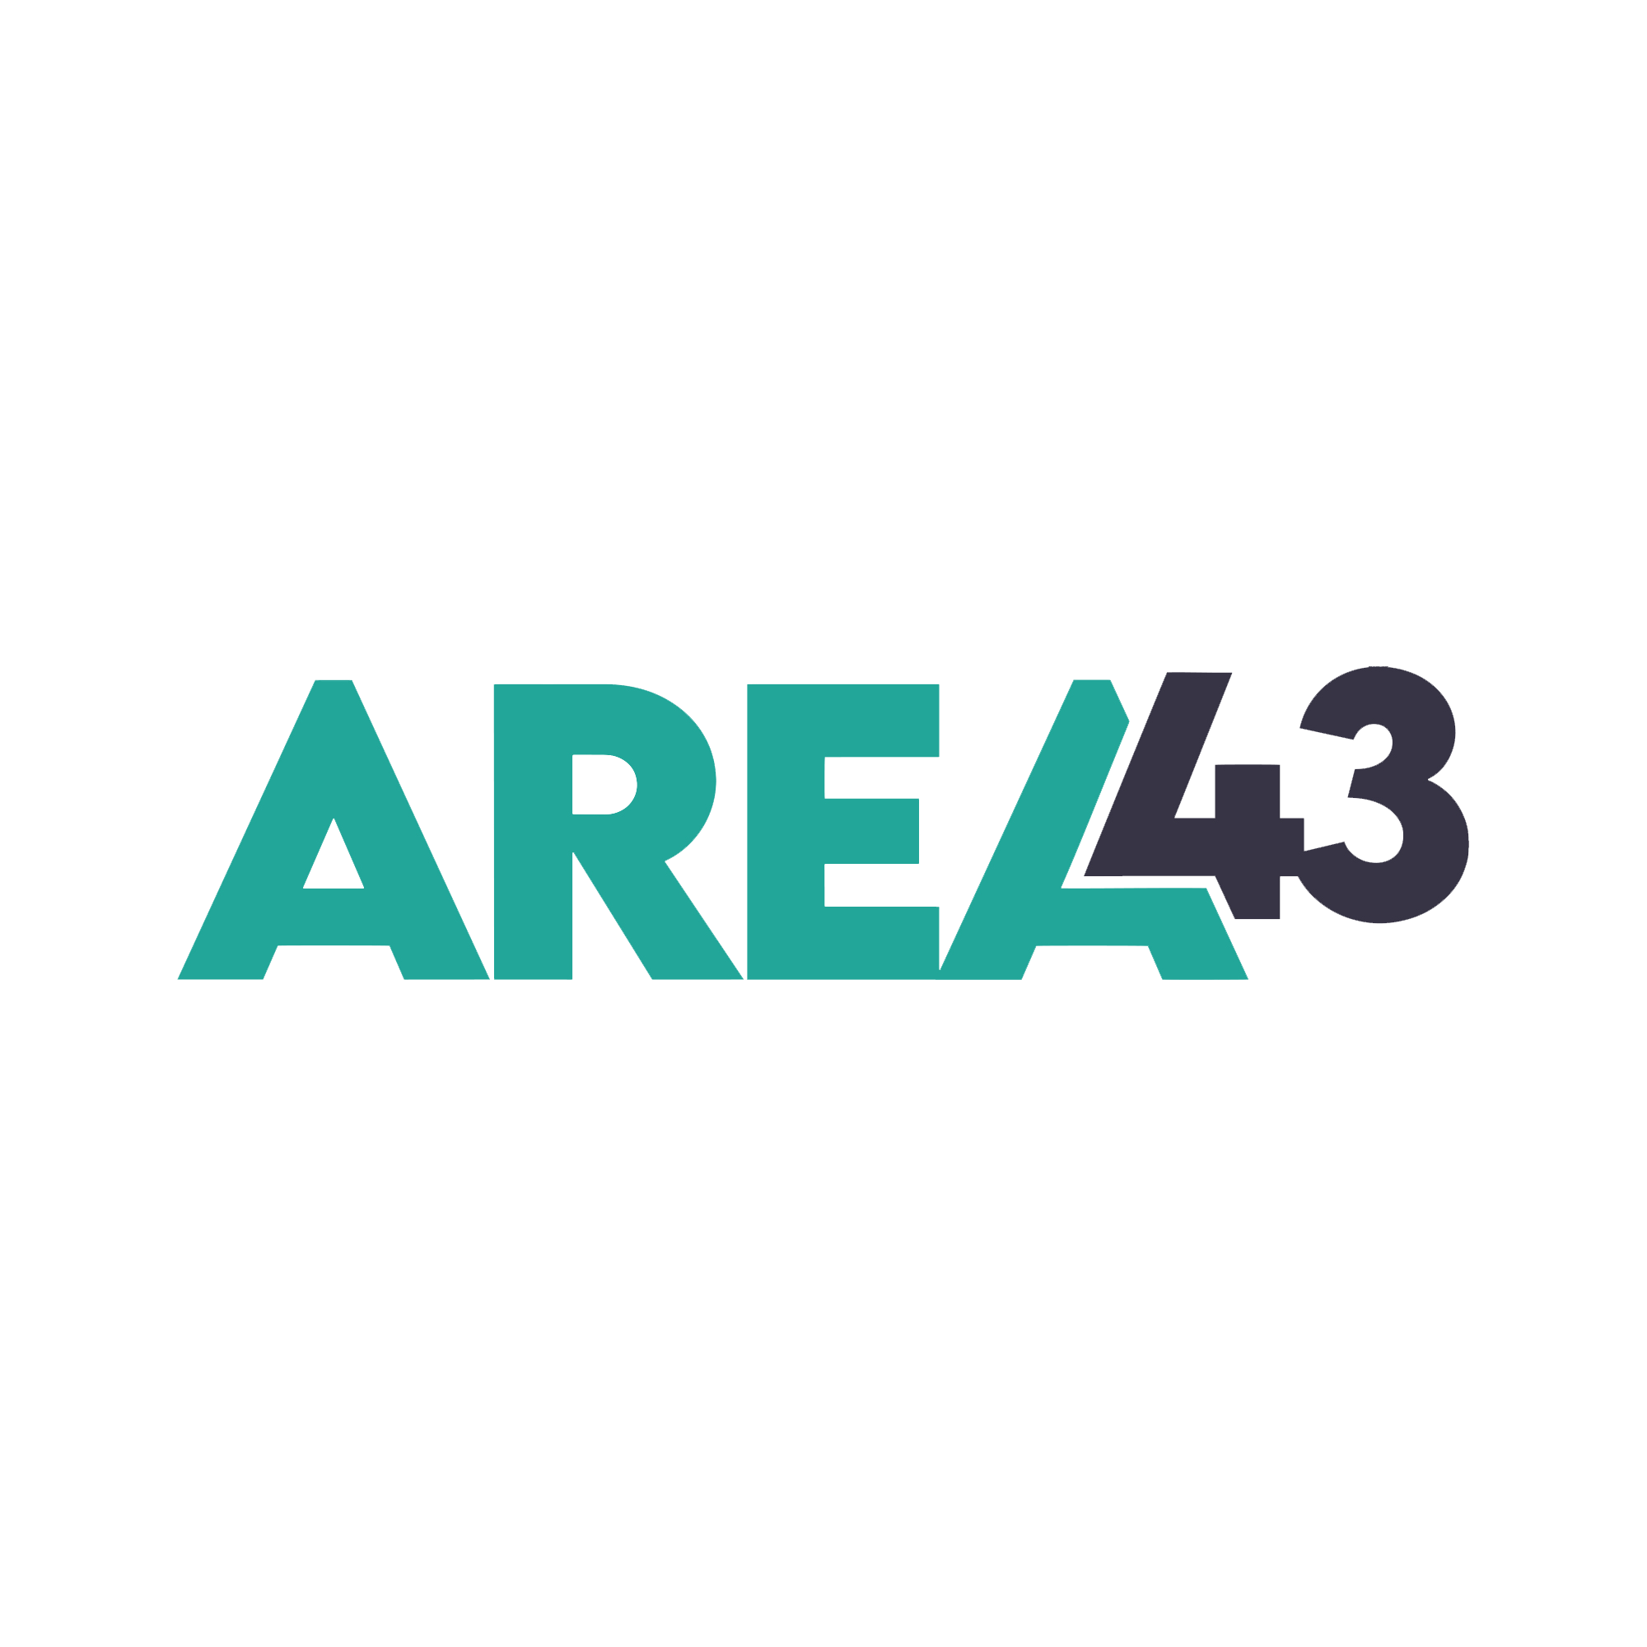Area 43
35 Pendre
Cardigan
SA43 1JS
01239 614 566

Welcome

Hello, and a warm welcome!
Thank you for your interest in working with Area 43, and for believing in our mission to empower and amplify youth voice, by advocating young people's rights to access local, high-quality support. We hope that you want to join us and work in partnership with young people and others to promote the development of free, youth-led services. At Area 43, we believe that young people have the power to change communities; they should always have somewhere to turn to and someone to talk to, regardless of location or circumstances.
For more than 25 years, Area 43 has provided drop-in and counselling support to vulnerable young people. We are proud of what we have achieved, but young people live in an ever-changing world and support services like Area 43 have an obligation to adapt and to listen to their voices, wants and needs. We have a responsibility to amplify young voices and to inspire them to be change makers.
This generation is growing up with new, emerging societal pressures exacerbated by the influence of social media and the polarisation of opinions on issues like misogyny, homophobia and transphobia. We must abandon the outdated notion that mental and physical wellbeing can be addressed in isolation from issues having an impact on mental health. It is our responsibility to help young people cope with issues that affect them before it gets to crisis point; they should have a community to turn to, no matter their location or circumstances.
We have an opportunity to make a serious commitment to young people’s mental health. This is an opportunity for parents, teachers and young people to stop whispering about their mental health needs and begin shouting for investment in its future.
We need to confront the issues around isolation, self-esteem and resilience to tackle the mental health concerns affecting young people head-on. Young people know what matters to them and should be leading organisations rather than fitting into them. We need to be youth-led, flexible, needs-led, trauma-informed and trustworthy. Young people need to know that they can come to us, not just when in crisis, but before they are in crisis, knowing that they will be heard, listened to and supported to make changes.
Services need to appeal to all young people, be open, inclusive and engaging. Non-threatening, fun and worthwhile experiences are crucial to ensuring young people can and will access services. So, should they ever be in crisis, they know where to turn for support.
We welcome people regardless of age, disability, gender identity, marital status, race, faith or belief, sexual orientation, socioeconomic background, and whether you’re pregnant or on family leave. In line with our commitments to race equity and trans inclusion, we particularly welcome applications from people who hold these identities. We are committed to changing services, making them relevant for today's young people.
We are committed to adapting our services to make them relevant for young people and challenging others to do so too.
If this aligns with your perspective, I do hope that you will apply for this position.
Sincerely

Rachael Eagles
Chief Executive Officer

Who We Are

Area 43 is based in Mid and West Wales, delivering youth-led services across the UK. We empower and amplify youth voice, advocating young people's rights to access local, high-quality counselling and support.

We want to see a world where:
- There are no barriers to support, and services are inclusive, accessible and fun.
- Other organisations follow our model to provide flexible, responsive, needs-led services which secure positive outcomes for individual children and young people.
- Our services, and those around us, unlock potential at every stage of young people's lives, especially where they face inequality or disadvantage.
- We contribute to the legal, policy and practice environment, advocating for children and young people.
- Young people are empowered to become involved in the local community, tackling issues of their generation.

Our Values
Trustworthy: We are supportive and non-judgemental. Young people can trust us to speak truth to power, and to amplify young voices.
Courageous: We are bold, brave and will take risks in order to get young people what they want and need.
Curious: Tell us something we don’t know. We love to learn, grow and delve into new projects!
Altruistic: We want to help. We care about young people and will do everything we can to support them to get where they need to go.
Disruptive: Change doesn’t happen without disruption, and like many young people we work with, we make good trouble!
Driven: We are passionate about helping young people achieve their goals and are driven to make change.

At Area 43, every member of staff makes a difference. We embrace individuality, celebrate our strengths and help each other grow, that’s what allows us to make things happen and makes us who we are.

Area 43 takes pride in its working culture and will continue to nurture our staff wellbeing across all our structures, enshrined in policy. Our staff are self-reflective, resilient, honest and dedicated and we do everything we can to ensure team wellbeing so they can perform to the best of their ability with the children and young people we support.

Our team are committed to ensuring a positive work environment, and pledge to:

Have fun and find the joy!
Be open and respectful to challenge
Be mindful of my actions
Be open and honest
Speak to the right person
Be my best self
Maintain clear boundaries
Remember that our differences can be our strengths

Youth-led
To be youth-led is to know when to step out of the way and let young people take the lead. Area 43 believes in young people’s abilities and ambitions and empowers them to make real change. Area 43 is youth-led from the outset, and we are determined to guide others to be youth-led too.

Area 43’s Safe Spaces
Our consultation proves that young people want to access services that are informal in nature and that they are less likely to attend targeted and formal locations: young people ask us for universal and open-access safe spaces.

Area 43 is committed to running safe spaces across Mid and West Wales, and sharing our knowledge with others across the UK, so we can help young people drive forward the change that they want to see. Young people tell us they need safe, dedicated, quality meeting spaces, where they can access support should they need it.

In more general terms, a safe space offers the following to young people:
- A relaxed meeting space, which is safe, friendly, and inclusive;
- A place for all young people from all social and cultural backgrounds to engage in social interaction with their peers in a safe and supportive drug and alcohol-free environment;
- A location for relaxation, recreation and entertainment and, where appropriate, as a site for information, signposting to services or even direct care/service provision;
- A place where young people can develop good quality relationships with their peers and with adults;
- An informal, educational space for young people to learn life skills and improve their opportunities for employment.
Safe spaces are non-traditional and therefore relatable, and attending the space carries absolutely no stigma or label. One of its key values is that whether a young person attends just to hang out with friends, drink coffee and listen to music, or attends to receive specific support to deal with a crisis, for all these purposes it looks the same and therefore fosters an inclusiveness that is so important to young people.
Area 43 is committed to meeting safe space requirements as defined in S³’s Manifesto (the Ceredigion Youth Lobby Group):
- Free at the point of access.
- A space for young people, by young people, set within a framework of trusted professionals.
- A space that communicates with young people and signposts to available services.
- A space that advocates for the rights and wellbeing of young people.
- A space where a young person can be vulnerable without being judged.
- A space where there is no stigma.
- A fully inclusive space.
- A space where you can be unapologetically yourself.
- A space where there are warm drinks and food, which is comforting.
- A space that encourages individuality.
- A space that can offer equity, stability, consistency, and reliability.
- A space that encourages a sense of community, and helps to build support networks.
- Somewhere that gives the service and service users an opportunity for early intervention in, and prevention of, mental health crises.

Area 43’s Counselling Service
Our counselling services are provided across the counties of Powys, Carmarthenshire, Ceredigion and Pembrokeshire for ages 5- 30, depending on the aspect of the service, whether within school settings, online, in the community, or at one of our Safe Spaces.

Area 43 recognises counselling as a purposeful process that allows clients to solve issues and grow confidence in their capacity to successfully contribute to their learning, personal, and social development. Our counselling provision is one way that Area 43 works to ensure that all of the children and young people we work with have the opportunity to reach their full potential.

The purpose of our counselling service is:
- To enable individuals to be more effective in their lives within and outside of Area 43 support
- To identify and provide conditions that will facilitate the wellbeing and personal development of clients.
- To provide a counselling service as an integral support mechanism for clients' learning.
- To reflect a commitment to the British Association of Counselling & Psychotherapy (BACP) Code of Ethics for Counsellors.

It is the policy of Area 43 that all clients should have equitable access to short-term counselling, normally 6, weekly sessions, which are:
- Free/Funded
- Impartial
- Client-centred
- Easily accessible
- Provided by those with relevant training and expertise
- Within a framework of confidentiality
- Provided by counsellors receiving appropriate supervision, working within BACP or equivalent ethical guidelines

We want to see a world where:
There are no barriers to support, and services are inclusive, accessible and fun.

Other organisations follow our model to provide flexible, responsive, needs-led services which secure positive outcomes for individual children and young people.

Our services, and those around us, unlock potential at every stage of young people's lives, especially where they face inequality or disadvantage.

We contribute to the legal, policy and practice environment, advocating for children and young people.

Young people are empowered to become involved in the local community, tackling issues of their generation.

Kitchen Supervisor

Contract: Permanent (subject to successful completion of 6 month probation)
Hours: 30 hours per week
Salary: £26,000 pro rata
Location: Based in Cardigan, Ceredigion, SA43 1JS
Benefits: Pension contributions: 3% employer; 5% employee
20 days holiday plus bank holidays (pro rata)

Area 43 is looking for a dynamic and enthusiastic kitchen supervisor for its youth café, Depot. Depot provides a safe space for young people across the county in a fun informal manner. We are seeking applicants who:
- Have experience working in hospitality.
- Have experience leading a team.
- Have experience supporting and growing new staff and / or volunteers.
- Are thoughtful towards colleagues.
- Are willing to embrace a fast-paced work environment.

How to Apply

If you would like to apply for this position, please send a CV and cover letter to HR@area43.co.uk. Applications from Indeed will not be considered.

Closing date: 18th May

Interviews: Week commencing 25th May
Please state in your application if you have any commitments during the interview period

Area 43 is committed to equality, inclusion and diversity and welcomes applications from all suitably qualified candidates. We are committed to providing a mutually supportive working environment where every individual is respected, valued and included.


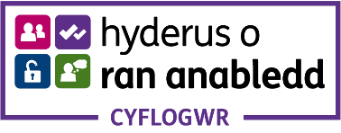

Job Description

Job Title: Kitchen Supervisor
Line Manager: Barista Trainer and Café Supervisor

Purpose of the Role
The Kitchen Supervisor role at Depot forms part of the cafe delivery team. The Kitchen Supervisor will support the Barista Trainer and Cafe Supervisor (BTCS) to maintain the functions of the cafe kitchen, including observing all hygiene, health and safety regulations. They will be responsible for maintaining paperwork, taking orders, managing the till and money-handling, checking and ordering stock, preparing hot food and beverages, and assisting with the day-to-day running of the cafe.
Working as part of a team which includes Barista placements under Depot’s training and employability scheme, the Kitchen Supervisor will help the BTCS to mentor young people on placement. The placement programme enables young people to gain skills and practical experience within a safe, supported environment, making their prospects within the wider economy more accessible to them by empowering them, to gain employment, and local businesses to address the labour shortage. The Kitchen Supervisor role will support this scheme, and provide leadership and on-the-job training for the Baristas on the scheme.
We want to inspire young people to become active community members through our projects, training, and employability skills.

Kitchen Supervisor duties include:
- Employability skills training
- Team player qualities
- Workplace knowledge, particularly hospitality and staff development
- Keyholder responsibilities
- Following Food Safety Guidelines:
- Allergens
- Safe Food Handling
- To represent the brand and culture of Depot and Area 43
- Great communication skills
- Customer service skills and knowledge
- Good level of literacy, numeracy, and IT skills.
- Attention to detail
- Ability to work unsupervised and deliver quality work
- Keeping your work areas clean and tidy

Main Responsibilities
- Effective day to day running of the cafe
- Assisting with mentoring young people on placement
- Ordering, receiving and storing stock supplies
- Stock checks and stock rotation
- Completing required training alongside your role
- Ensuring the smooth running of the cafe kitchen
- Event planning and budgeting

Person Specification

Essential qualities:
- Previous experience in a hospitality role
- A team player with good motivational skills
- Reliable and ready to learn new skills
- Enthusiasm to develop your skills and knowledge
- A positive and approachable manner
- Openness to new challenges, to develop and grow personally
- Competence with IT systems and relevant paperwork (e.g. kitchen checklists, money-handling)

Desirable qualities:
- The ability to speak and understand Welsh is desirable but not essential
- Already holding Food Hygiene Level 2 and Allergen Awareness qualifications (if you do not have these, training will be provided)

April 2026

